



SETUP DOCUMENT

LARP EVENT SOFTWARE SOLUTION

Version 2.0

Dholon Akter | Nr. 3047040

Chanelle Hart | Nr. 3323781

Talia Santos | Nr. 3294579

Thanh Hoàng | Nr. 3353362

GROUP 34

# Version History

|  |  |  |  |  |  |
| --- | --- | --- | --- | --- | --- |
| **Version #** | **Implemented By** | **Revision Date** | **Approved By** | **Approval Date** | **Reason** |
| 0.5 | T. Santos | 6th Mar | - | - | Rough draft |
| 0.6 | C. Hart | 9th Mar | - | - |  |
| 1.0 | T. Hoàng | 11th Mar | - | - | Add GUIs, Wireframes, ERD |
| 2.0 | T. Hoàng | 18th Mar | - | - | Finalization |

Table of Contents

Version History 2

Agreements 4

Processes 4

Functional Requirements 4

GUI 5

Wireframes 22

Visual Design 39

ERD 56

# Agreements

**Applications:**

* The applications should have functionalities supporting the management of the events.
* The applications will run on Windows.
* The applications should be user-friendly and accessible to all personnel.
* The applications for stores and loan stands should be self-service.

**Website:**

* The website should have functionalities supporting the purchase and/or reservations of tickets and camping spots.
* The website should be visually appealing and informative to potential visitors.
* All personal information on the website will be carefully stored.
* The website will be able to run on mobile devices.

# Processes

For ease of visualization, all processes which can or may occur during user and application interaction are listed under the GUI.

# Functional Requirements

|  |  |  |  |  |
| --- | --- | --- | --- | --- |
|  | **Must have** | **Should have** | **Could have** | **Won’t have** |
| **Website** | * Informative * Visual appeal * Reserve/purchase tickets and camping spots * Information safely stored | * Responsive for all mobile devices | * About page for the company * About page for the events * Room for feedback * Links to social media * Picture gallery | * Transactions will not be processed on the website but will be redirected to a third party. |
| **Applications** | * Monitor visitors: enter, exit and quantity. * Stores and loan stands are self-service * Clear overview of event for organizers * Retrieves transactional logs and handle them * Run on Windows | * A clear maintenance terms and contract * User-friendly * Manuals | * A mobile app for the stores and loan stands |  |

# GUI

**Overview application**

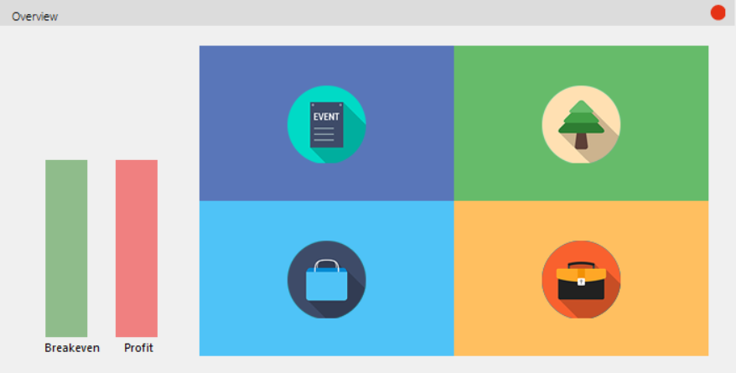

The overview application consists of 4 main tiles:

1. Event overview
2. Camps overview
3. Shops overview
4. Staff overview

Hover over the tiles will show their functions; clicking on one of them will show a corresponding window for that section.

The breakevent column represent percentage till the event hits its breakeven point and can start generating profit.

The profit column represent percentage of profit the event has made based on its investment.

Example: If a client invests $1,000 in an event and the event generates $800, then the breakeven will be at 80% and the profit 0%. If the event generates $1,200, then the breakeven will be at 100% and the profit 20%.

*Event overview*

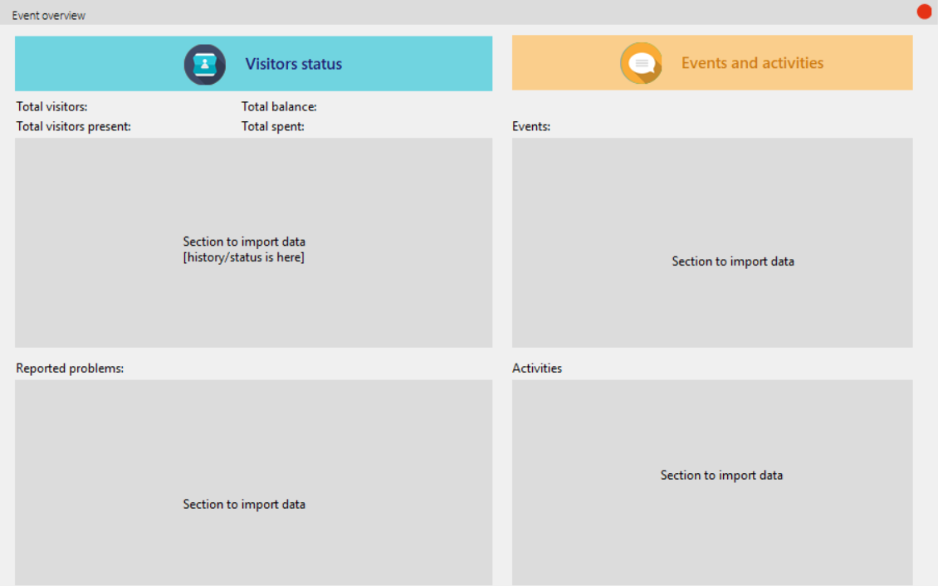

1. Visitors status

The information about the visitors and the activities within the event is shown here.

This section will have its data imported from a database, which will contain information about all the visitors currently present.

The section ‘Reported problems’ will show the issues which visitors have reported and whether or not they have been resolved.

1. Events and activities

This section will have its data imported from a database, which will contain the time and location for current and/or upcoming events and activities.

*Camp overview*

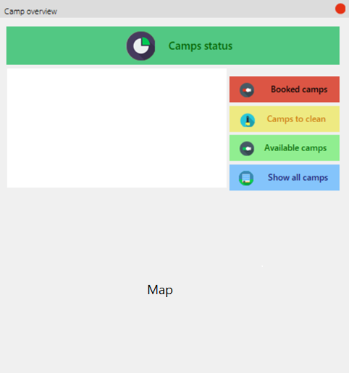

Once user clicks on one of the buttons, the corresponding information will be shown on a listbox to the left.

The section for the map will display the campsite’s map with symbols marking the camps as well as their status.

*Shop overview*

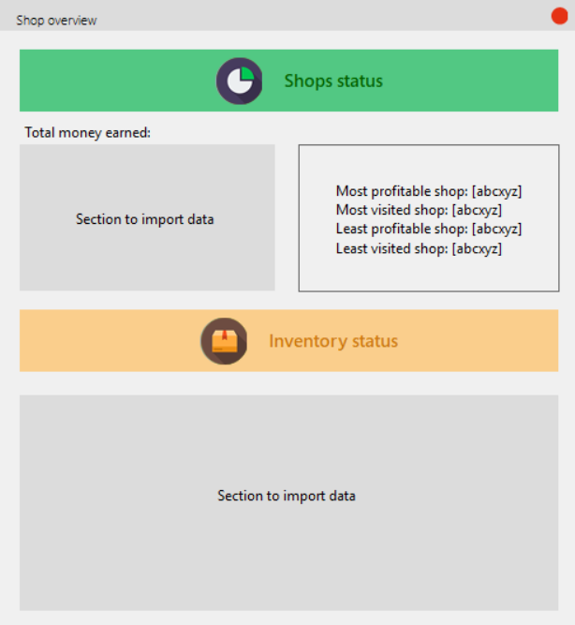

1. Shop status

The total money earned by shop will be shown via a query from the database, which will be imported in the corresponding section.

Retrieving information in the database, we can also display a ranking of shops in the section to the right.

1. Inventory status

Inventory status will have its data imported from a database, showing all the items currently in stock and those which will need to be restocked soon.

*Staff overview*

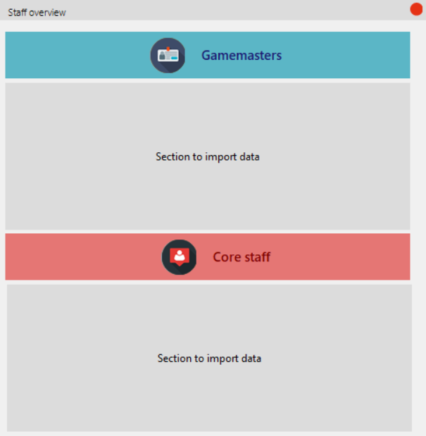

1. Gamemasters

LARP Events consist of gamemasters located all around the terrain to aid players with their experience. This section will show the gamemasters’ information as well as location.

1. Core staff

This section will show information as well as the location of all the staff who are not gamemasters.

**Entrance of event**

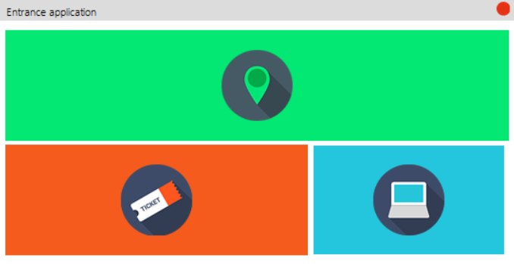

The entrance application consists of 3 main tiles:

1. Check in
2. Check out
3. Monitor visitors

Hover over the tiles will show their functions; clicking on one of them will show a corresponding window for that section.

*Check in*

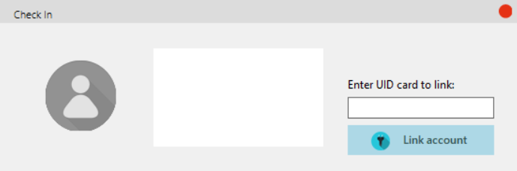

Once a visitor scans their ticket, their details will show up in the listbox, as well as their picture. The staff can then proceed to enter the Unique Identification of the card they want to link the visitor with

**Link account**: Performs the linking action

*Check out*

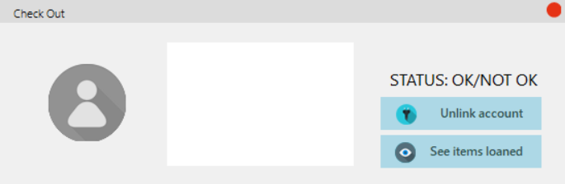

Once a visitor scans their ticket, their details will show up in the listbox, as well as their picture. If they have unreturned item(s), their status will show up as “NOT OK” and the item(s) which they have not returned will show up in the listbox; otherwise, their status will be “OK” and they are free to leave.

**Unlink account**: Performs the unlinking action: user information will be removed from the card.

**See items loaned**: Display all the items not returned from the events (regardless of who has not returned them)

*Monitor visitors*

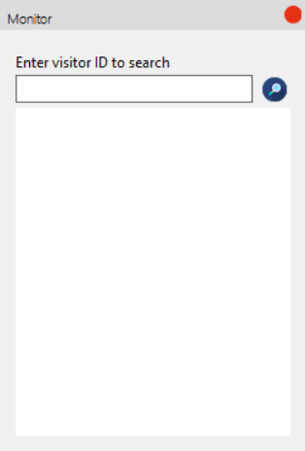

The staff can enter a visitor ID to search, clicking on the magnifying glass will show their details in the listbox.

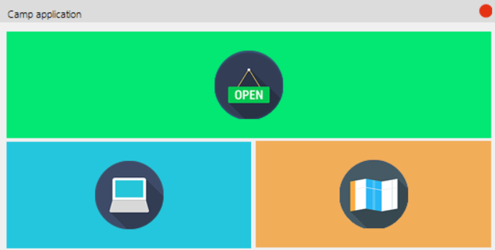**Entrance of campsite:**

The entrance application consists of 3 main tiles:

1. Check in
2. Monitor reservations
3. Camp status

Hover over the tiles will show their functions; clicking on one of them will show a corresponding window for that section.

*Check in*

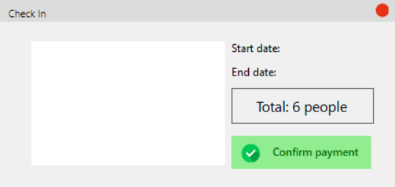

After the user has scanned their ID, their group’s information will show up in the listbox, together with the start date and end date of their reservations. The total number of people will also be updated.

Once the payment process has been sorted out, clicking on **Confirm payment** will greenlight the group’s status and they are checked in.

*Monitor reservations*

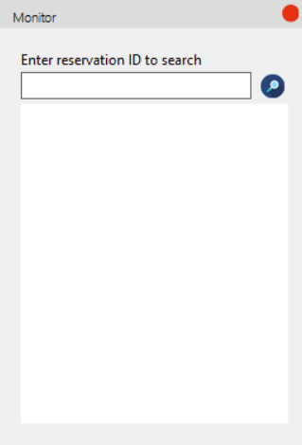

The staff can enter a reservation ID to search, clicking on the magnifying glass will show their details in the listbox.

*Camp status*

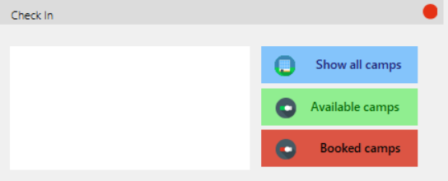

Once user clicks on one of the buttons, the corresponding information will be shown on a listbox to the left.

**Store application**

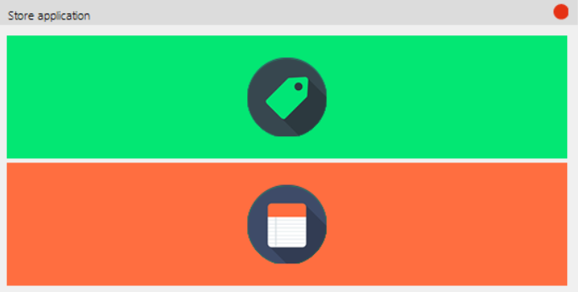

The store application consists of 2 main tiles:

1. See products – to display all products available
2. See cart – to display products which the user has selected

Hover over the tiles will show their functions; clicking on one of them will show a corresponding window for that section.

*See products*

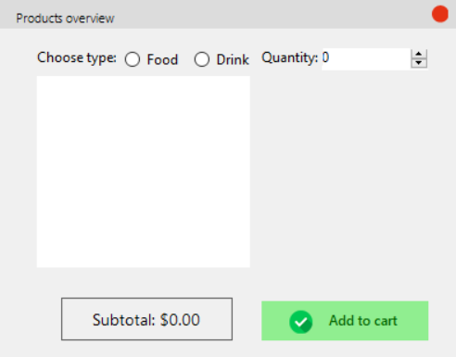

User will choose their type of products: Food or Drink. The available products for their respective choice will display as they click on the radio button.

If they select an item in the listbox, the picture of said item will show up in the area to its right. The picture will change if the user selects one item. If the user selects multiple items, the images will not display.

Once they have selected their item(s), the user can increase or decrease the quantity to order.

The subtotal will automatically update as the user interacts with the software.

**Add to cart:** Once they are sure that they want certain products, they can click on this button to add them to their order

*See cart*

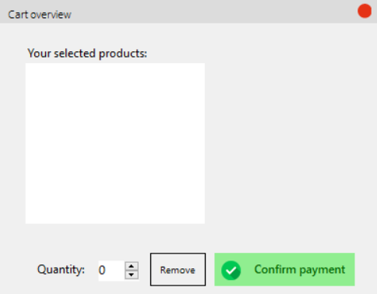

Details about what the user ordered will be displayed in the listbox.

If they select an item in the listbox, the picture of said item will show up in the area to its right. The picture will change if the user selects one item. If the user selects multiple items, the images will not display.

**Remove**: The user has the option to modify the quantity they have ordered earlier and clicking on this button will execute the action.

**Confirm payment**: Clicking on this button will confirm and process the order.

**Store application**

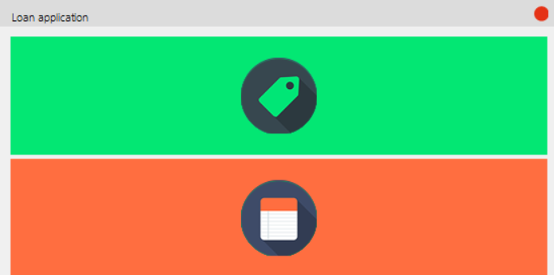

The loan application consists of 2 main tiles:

1. See products – to display all products available
2. See cart – to display products which the user has selected

Hover over the tiles will show their functions; clicking on one of them will show a corresponding window for that section.

*See products*

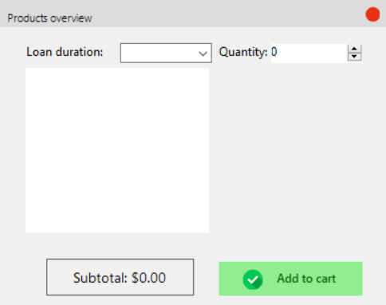

The information about the available items to loan will be shown in the listbox.

If they select an item in the listbox, the picture of said item will show up in the area to its right. The picture will change if the user selects one item. If the user selects multiple items, the images will not display.

The user can select the given loan duration for their item(s) of choice.

Once they have selected their item(s), the user can increase or decrease the quantity to loan.

The subtotal will automatically update as the user interacts with the software.

**Add to cart:** Once they are sure that they want certain products, they can click on this button to add them to their order

*See cart*

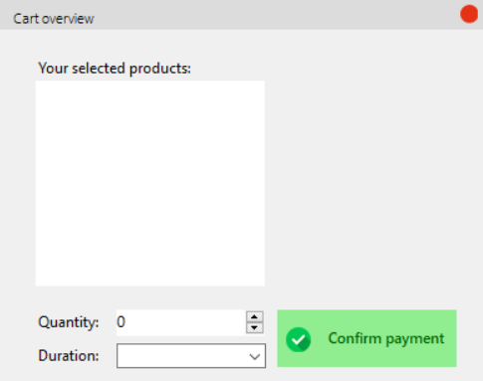

Details about what the user ordered will be displayed in the listbox.

If they select an item in the listbox, the picture of said item will show up in the area to its right. The picture will change if the user selects one item. If the user selects multiple items, the images will not display.

If the user wants to modify the quantity or the duration of their loan, they can select item(s) in the listbox and modify the values of the given input forms.

**Confirm payment**: Clicking on this button will confirm and process the order.

# Wireframes

**Homepage:**

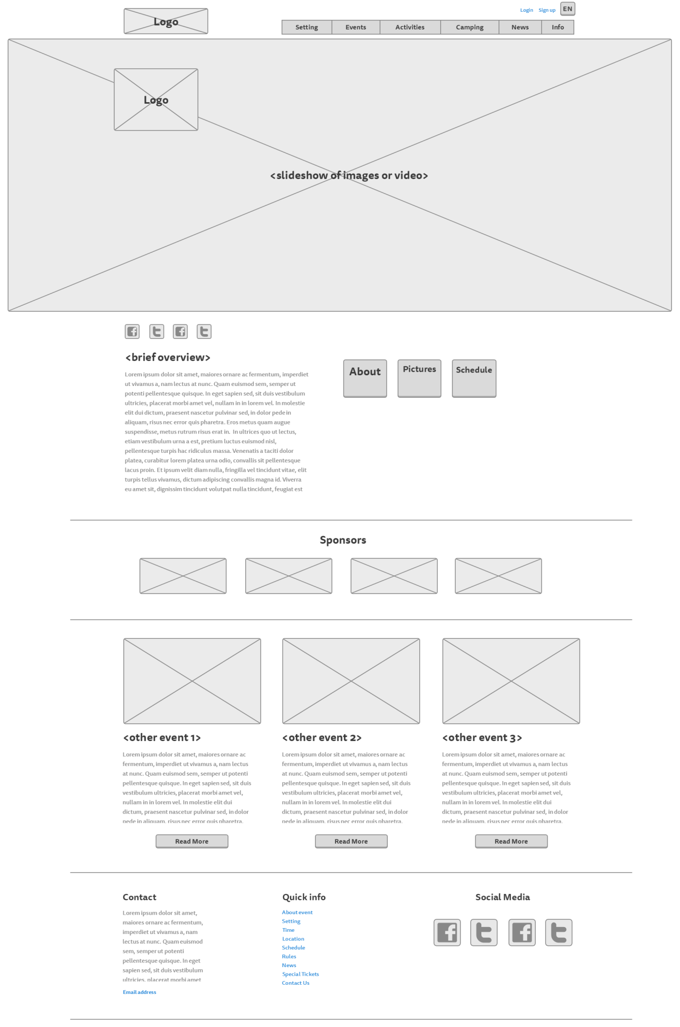

**Setting page:**

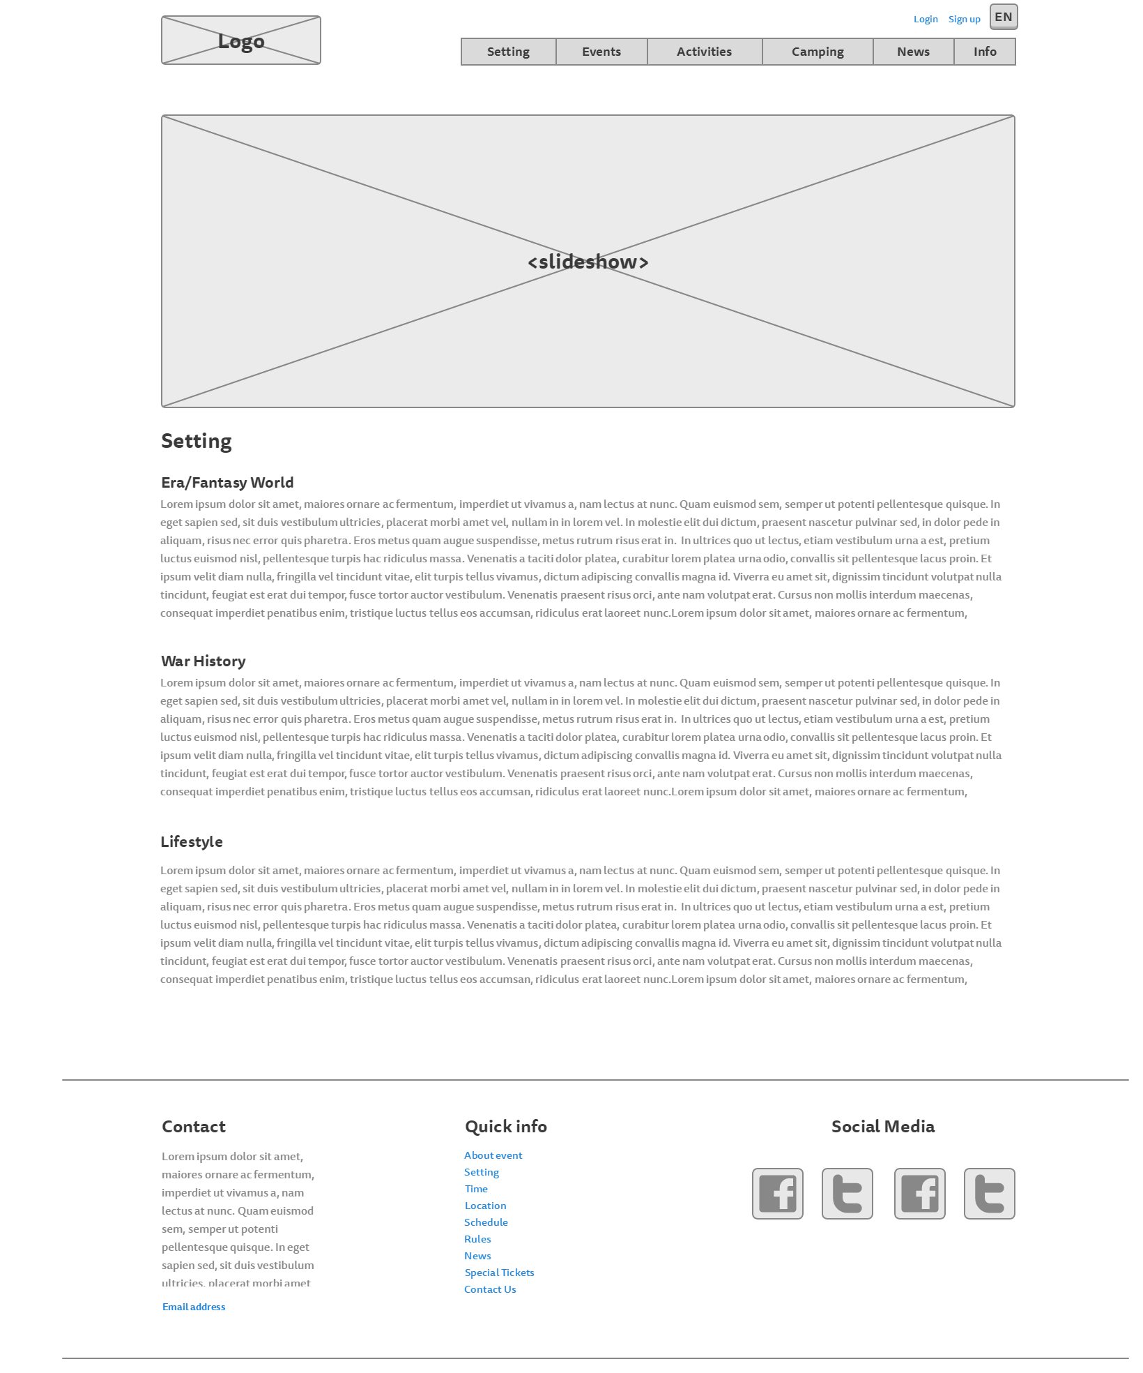

**Rules page:**

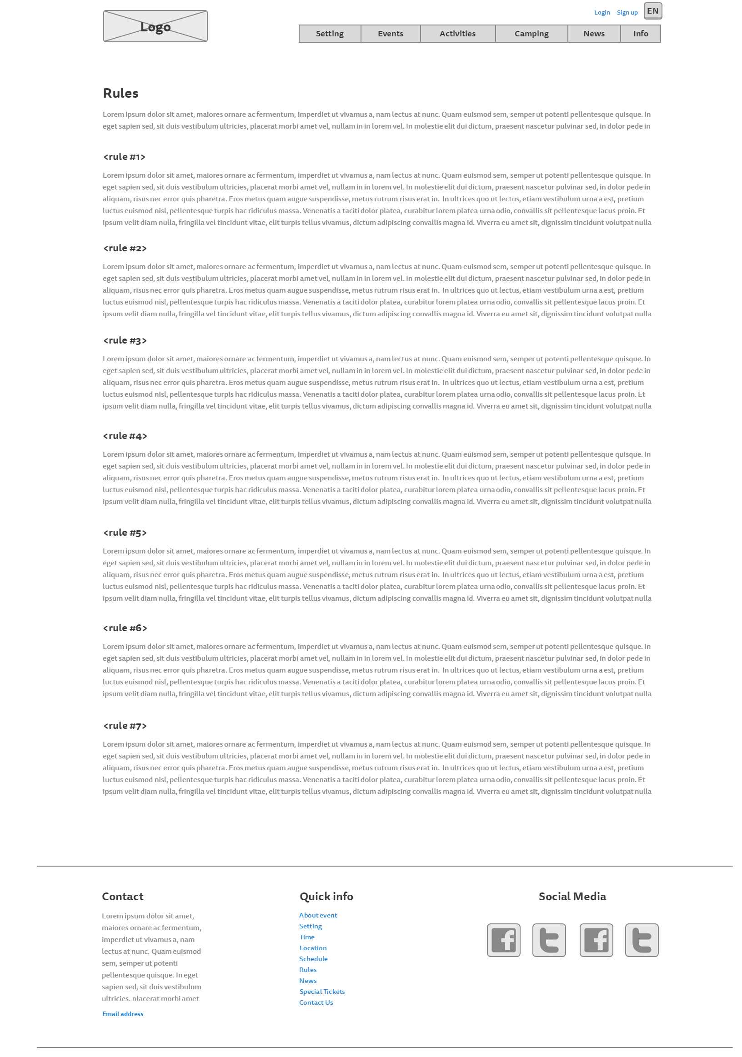

**Events page**

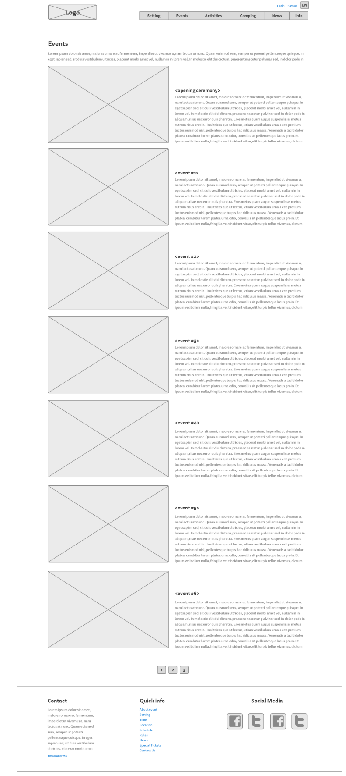

**Activities page:**

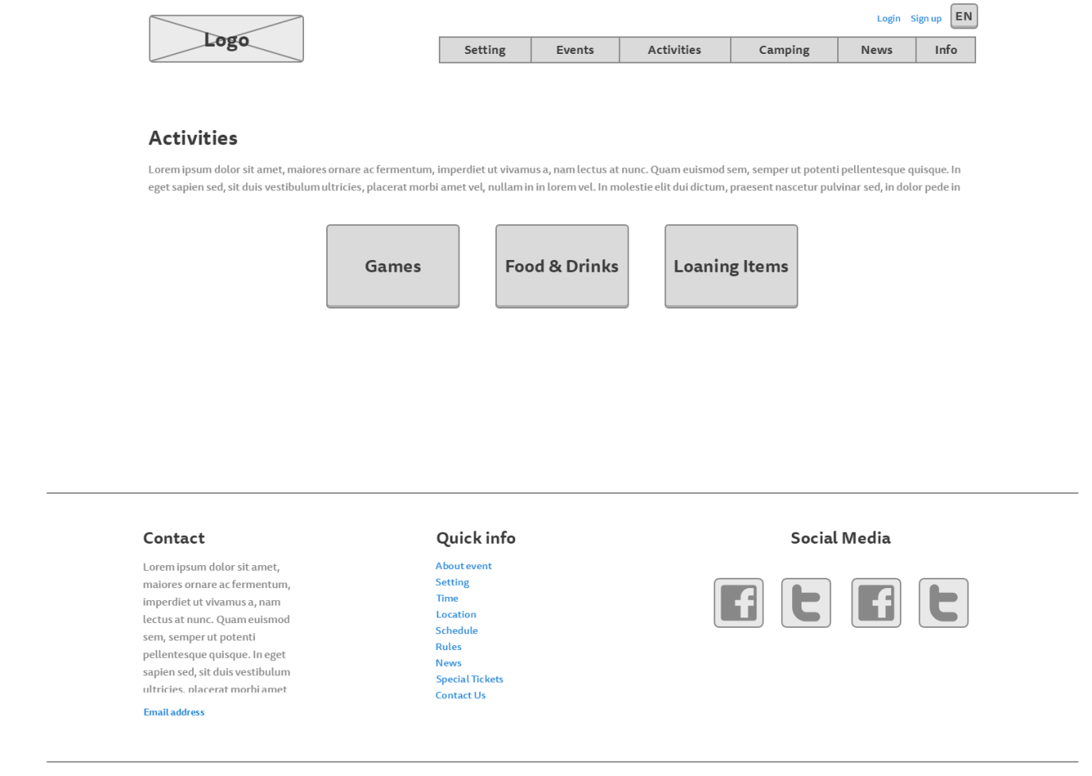

**Food, drinks and loaning items page**

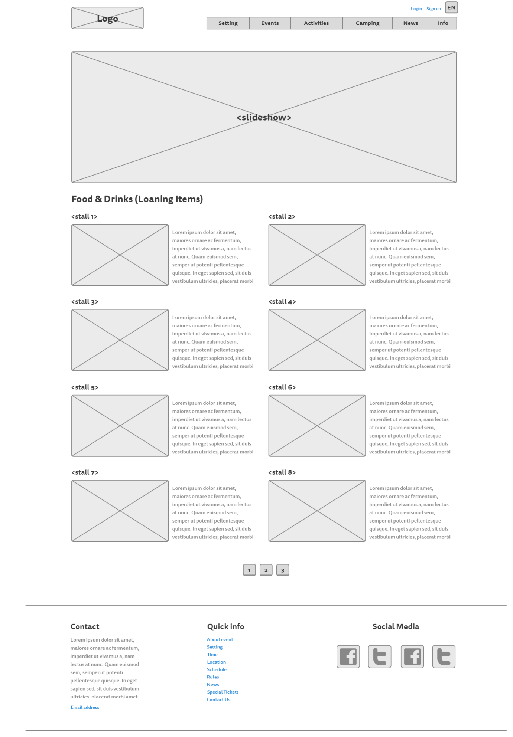

**Games page:**

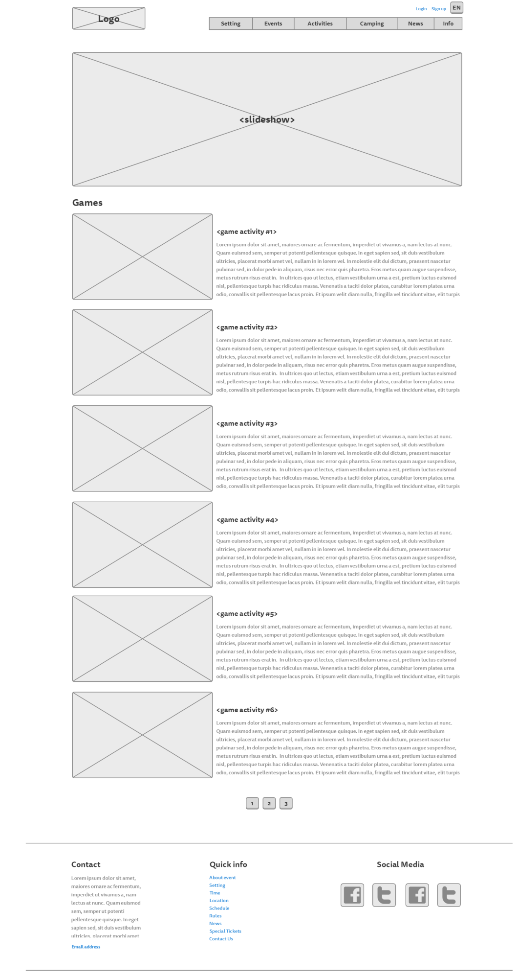

**Camping page:**

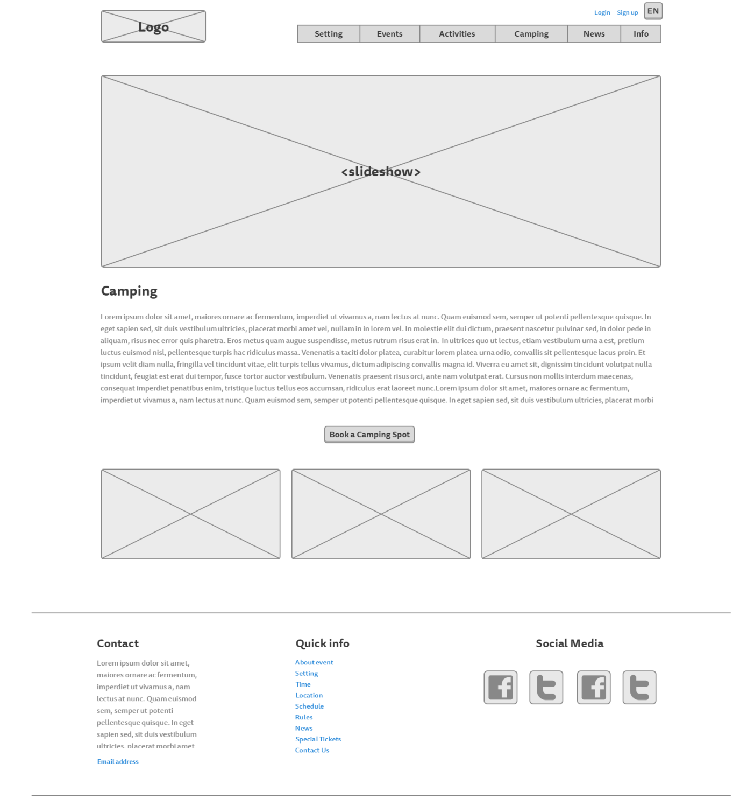

**News page:**

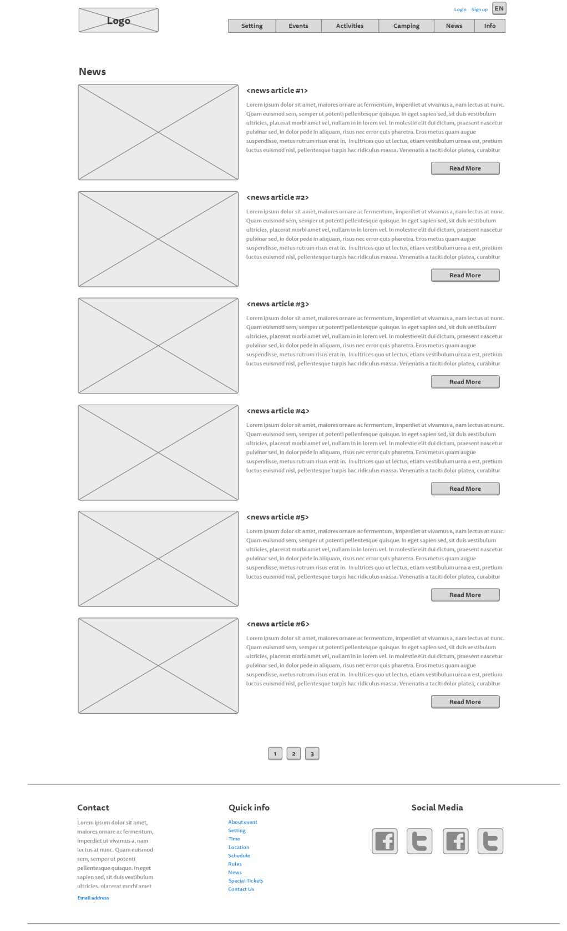

*News – read more:*

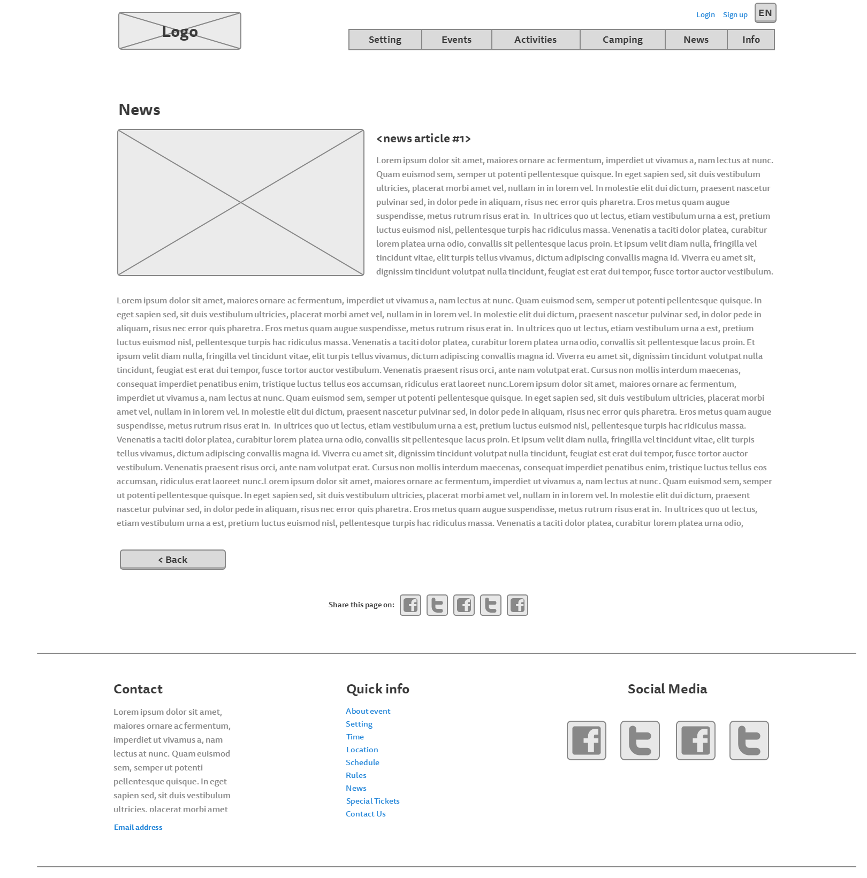

**About page:**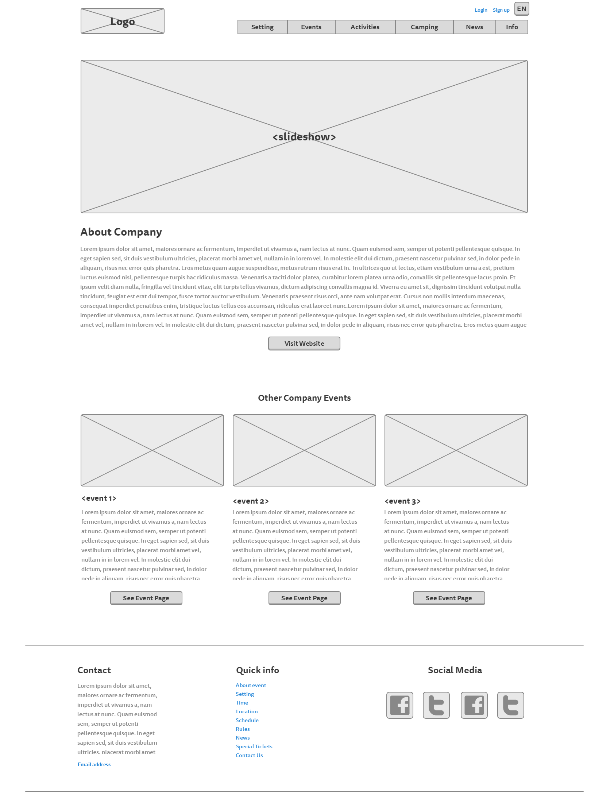

**Login page:**

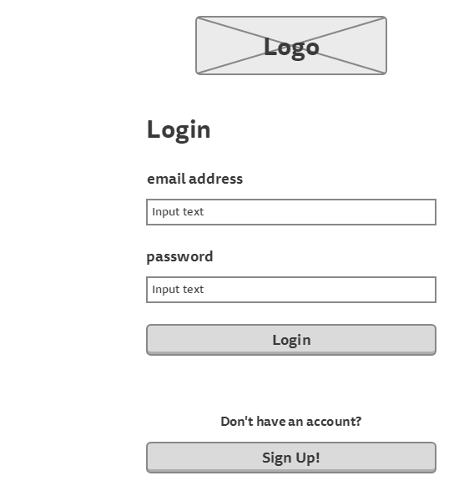

**Sign up page:**

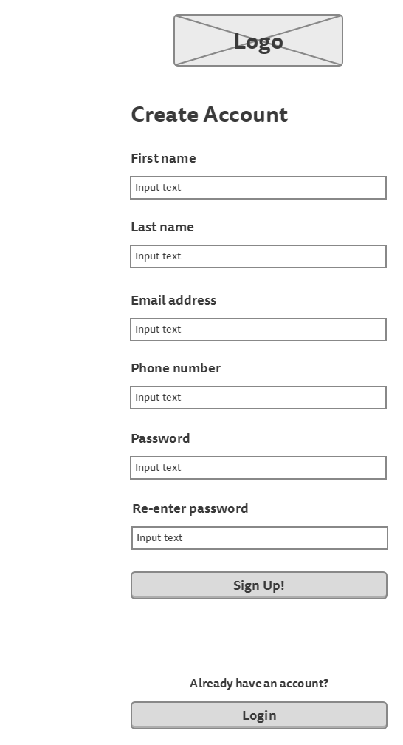

**Participant’s information page** (to show tickets information)

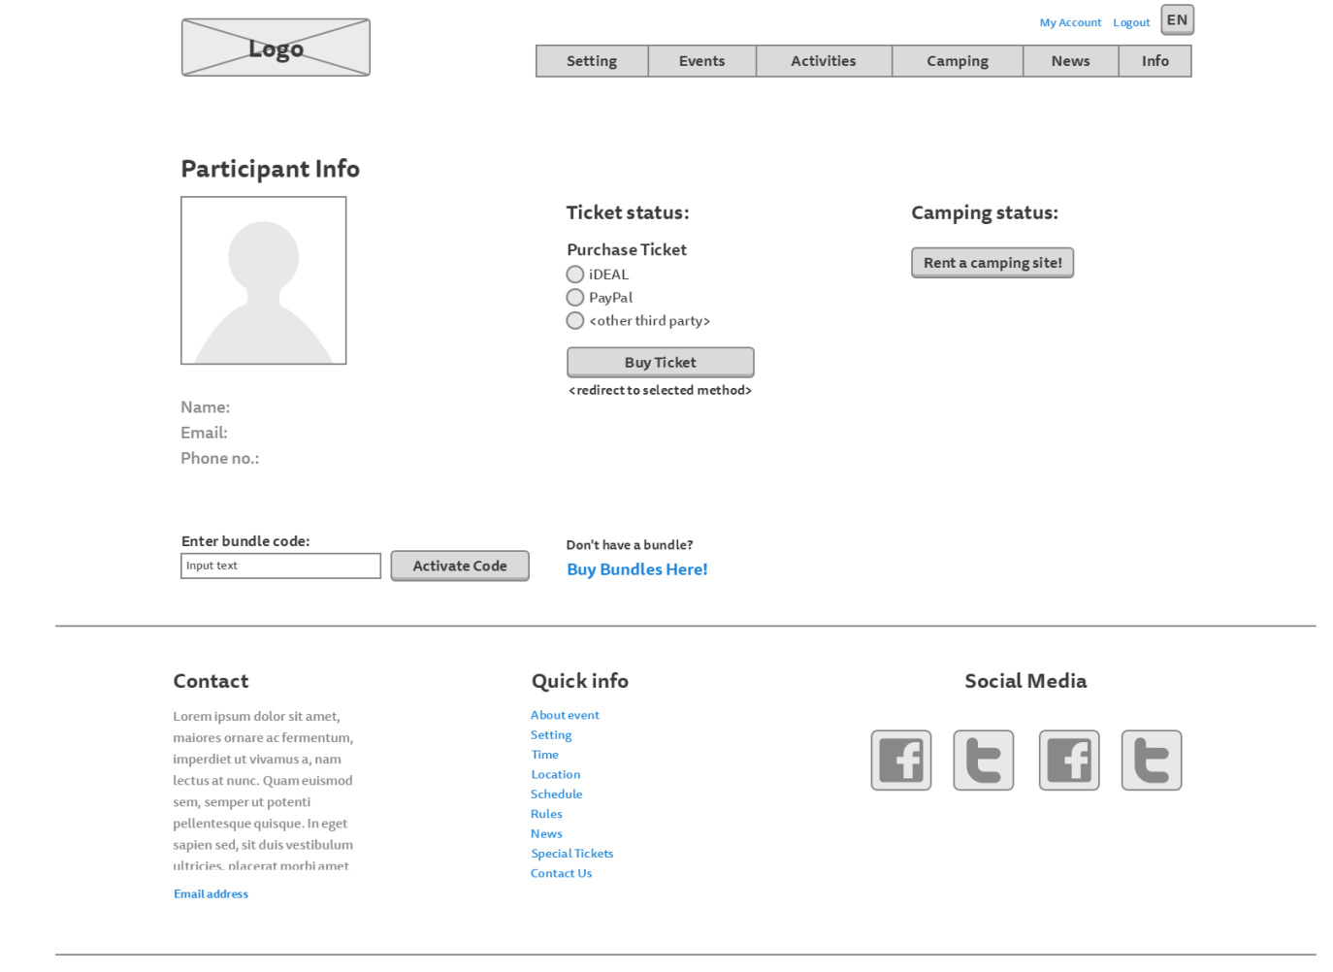

**Participant’s information page** (to show camping information)

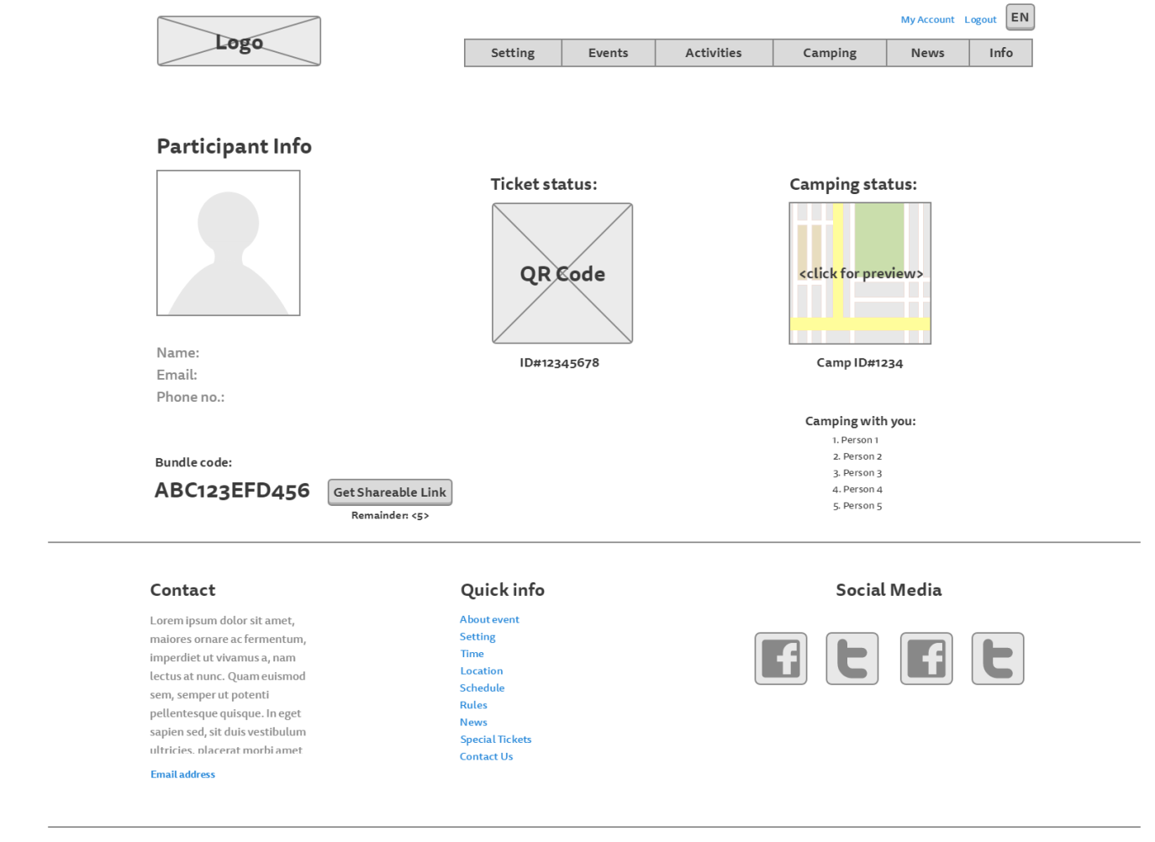

**Camping registration page:**

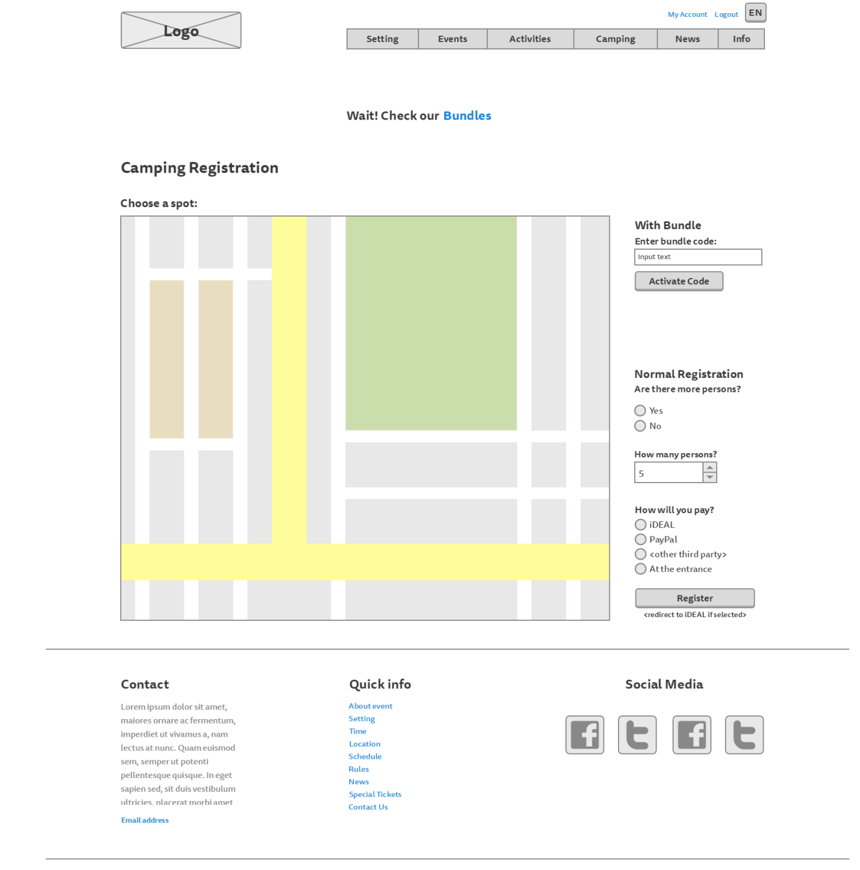

**Bundles page:**

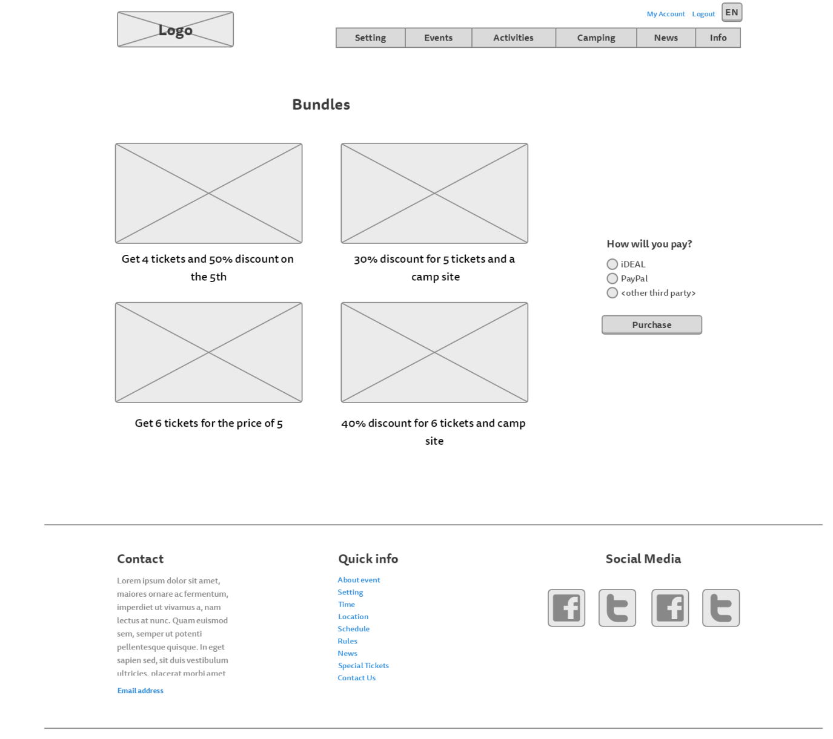

# Visual Design

**Homepage:**

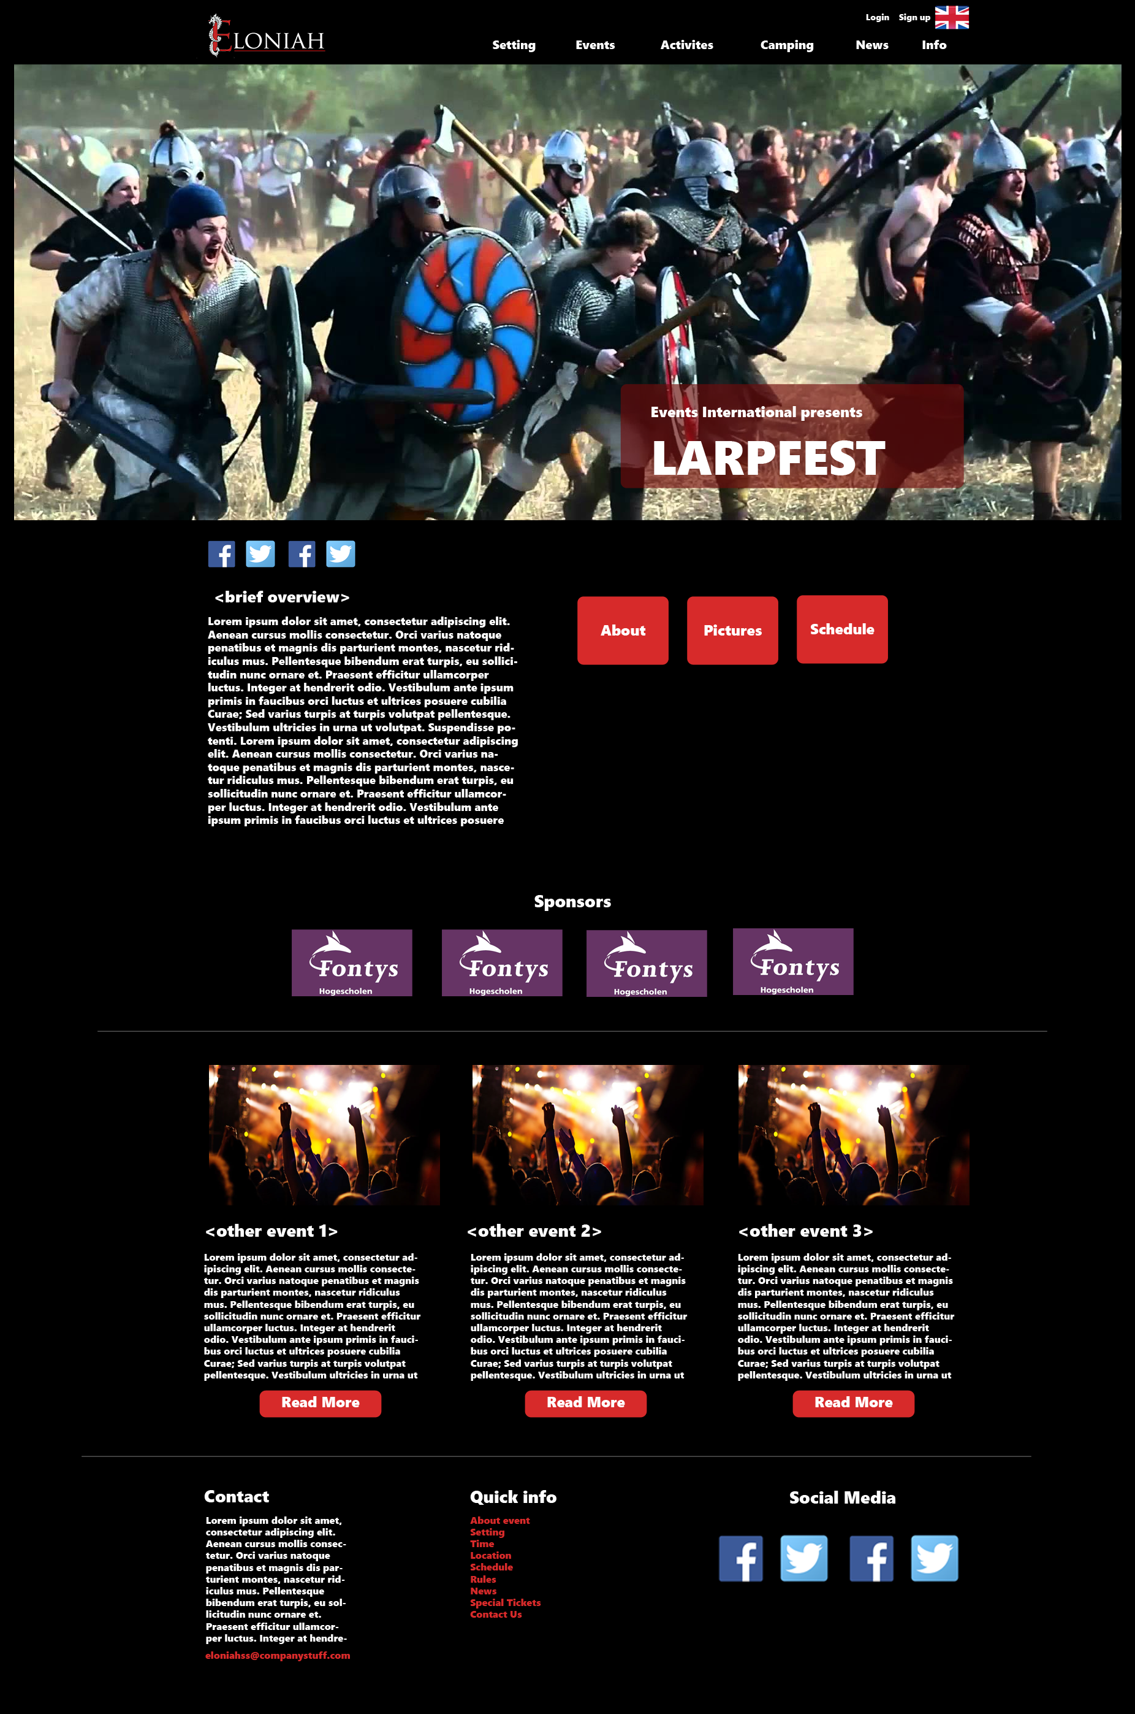

**Setting page:**

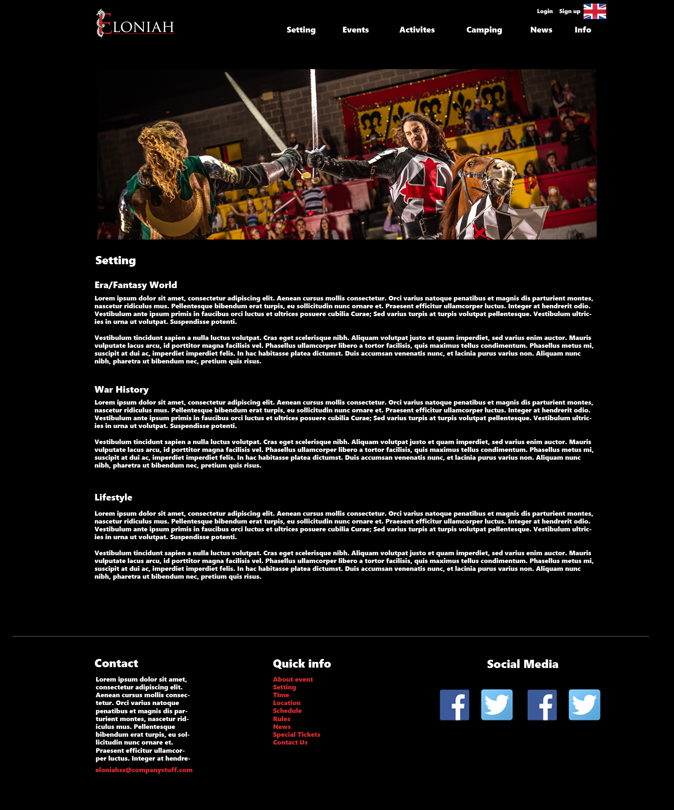

**Rules page:**

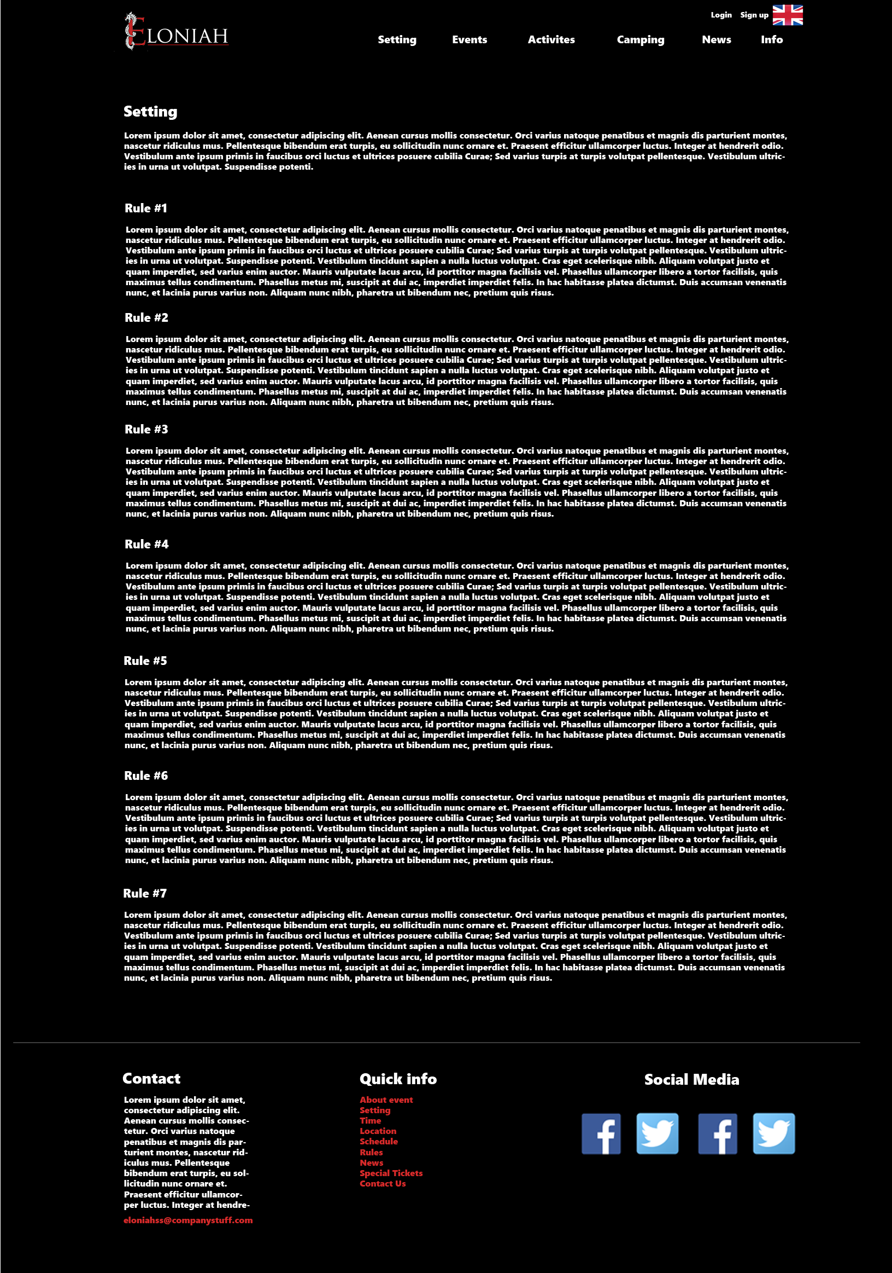

**Events page**

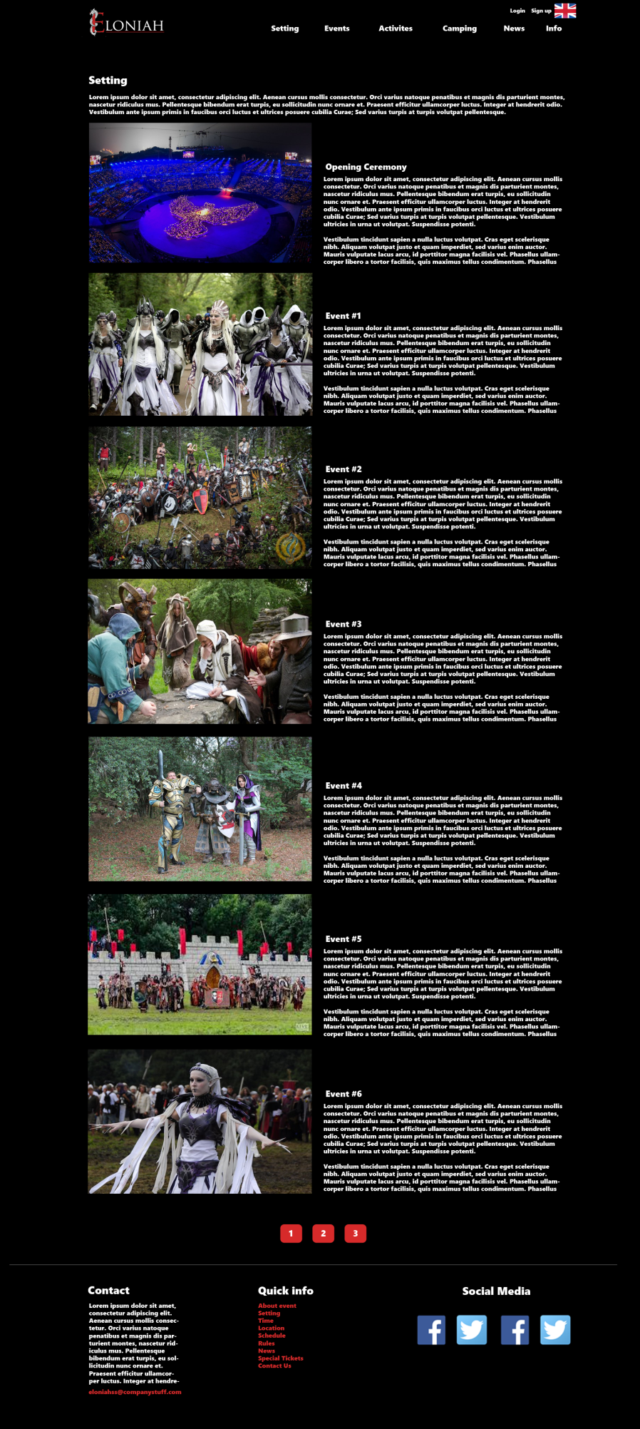

**Activities page:**

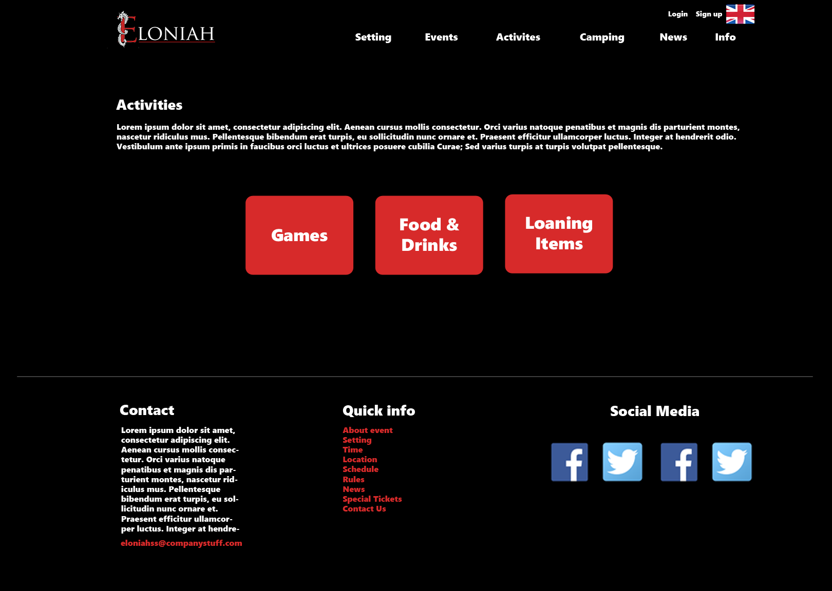

**Food, drinks and loaning items page**

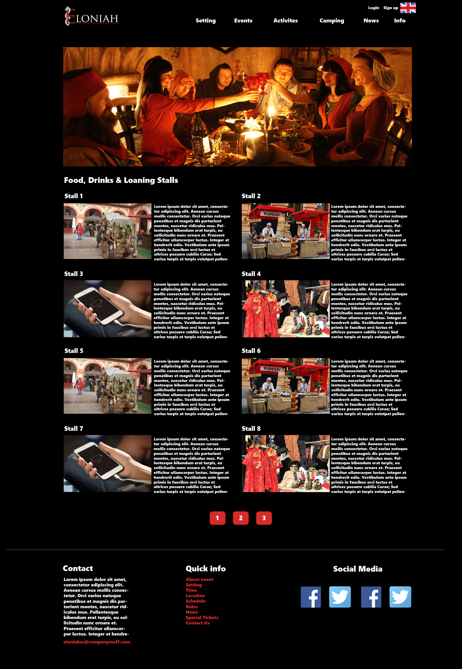

**Games page:**

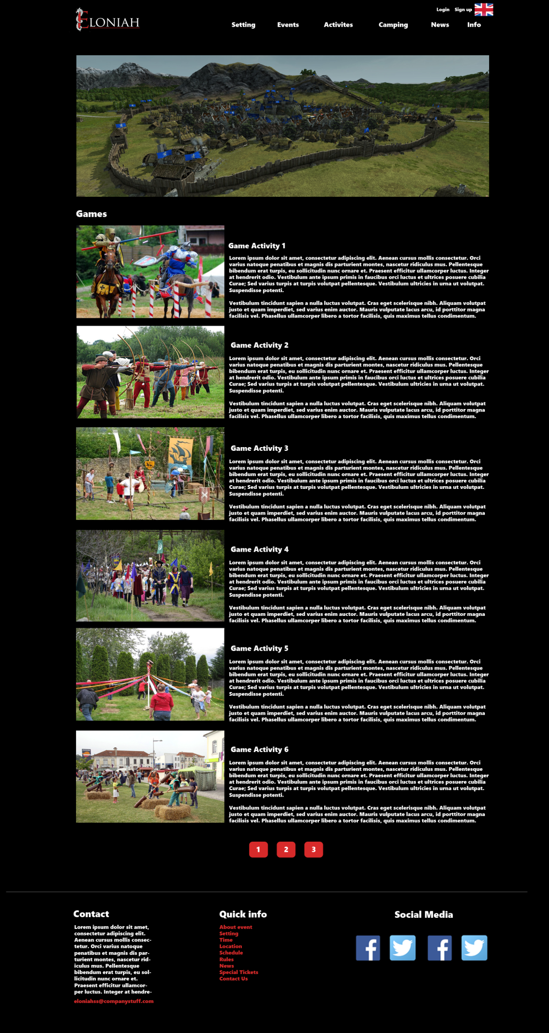

**Camping page:**

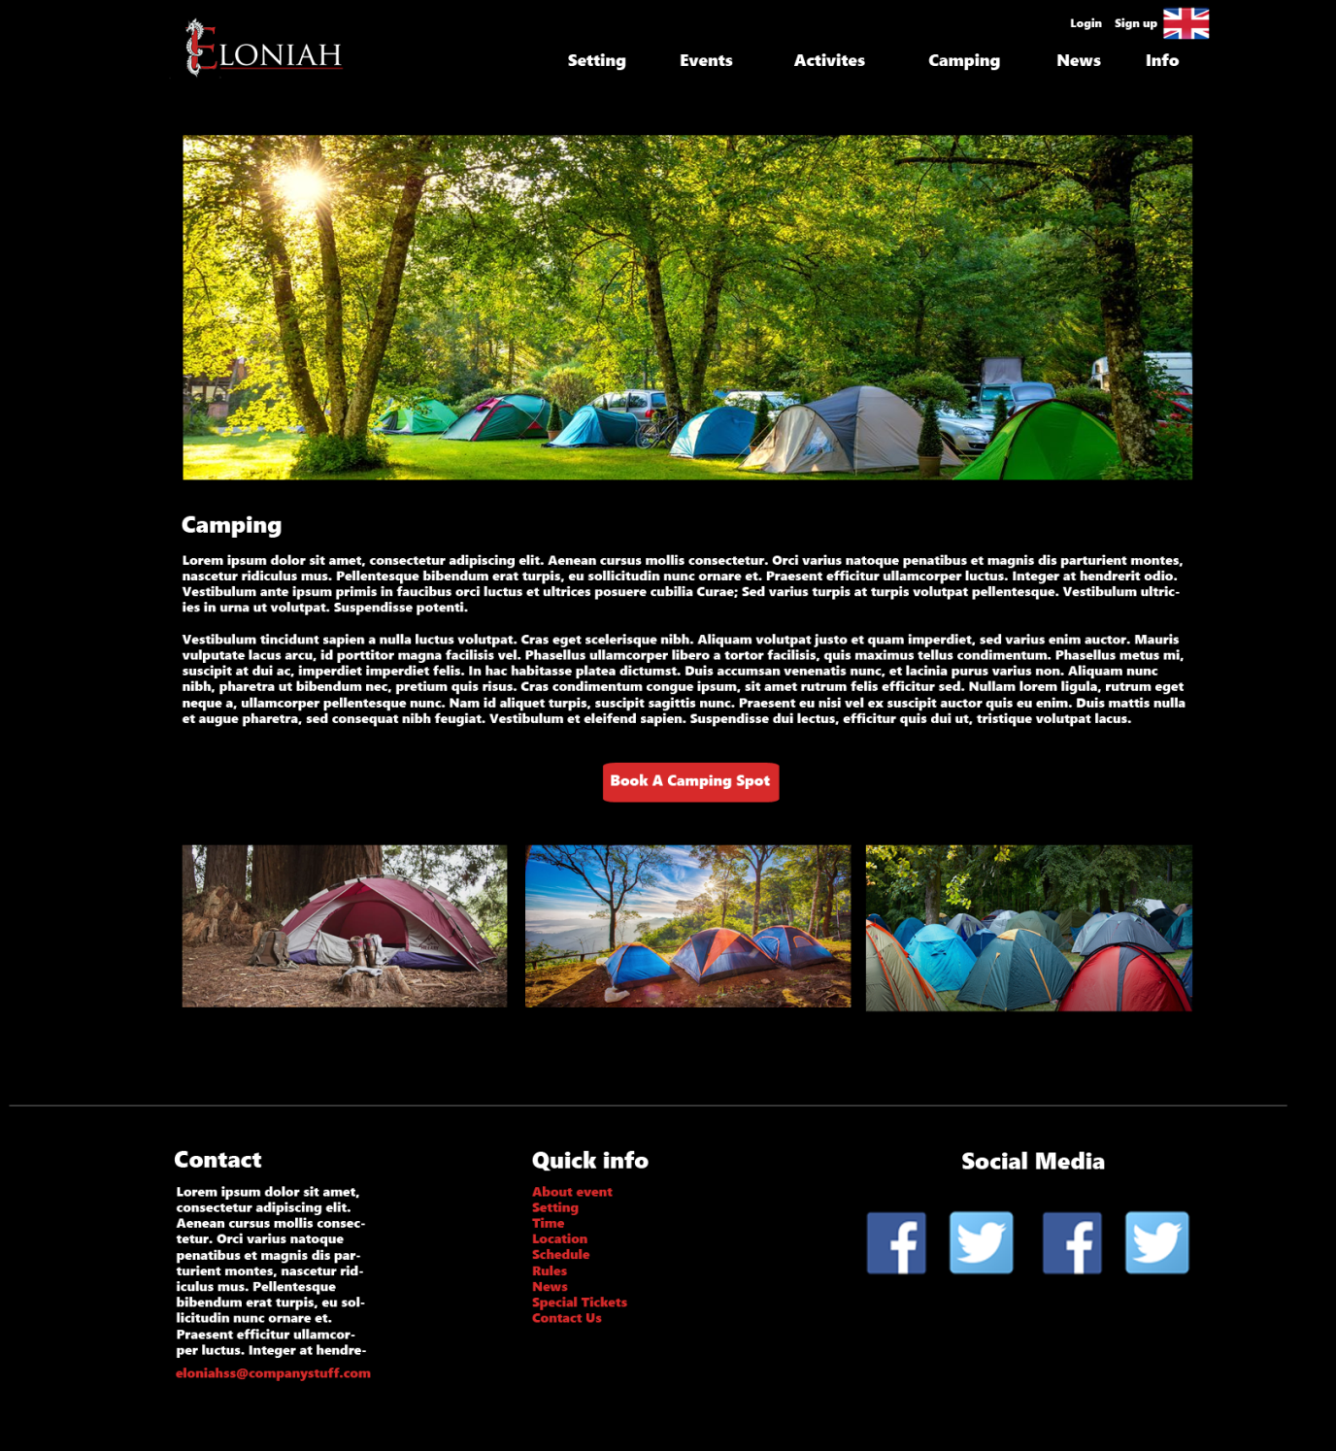

**News page:**

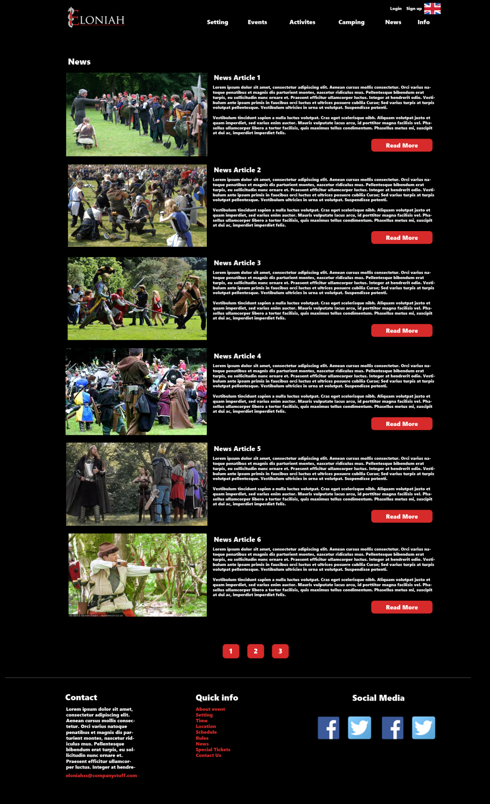

*News – read more:*

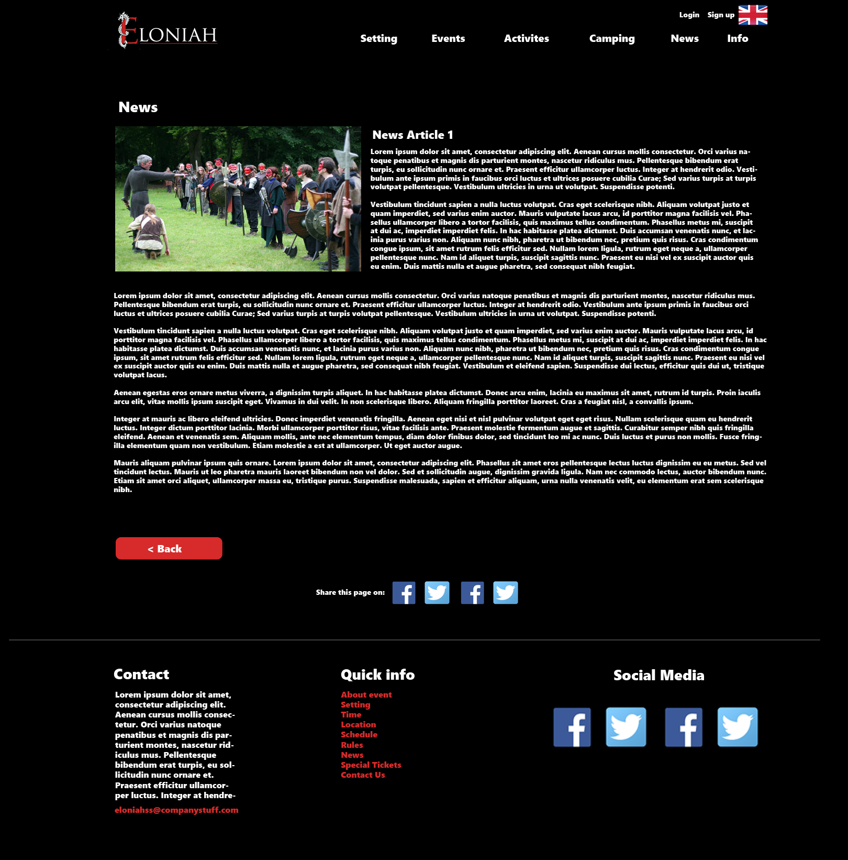

**About page:**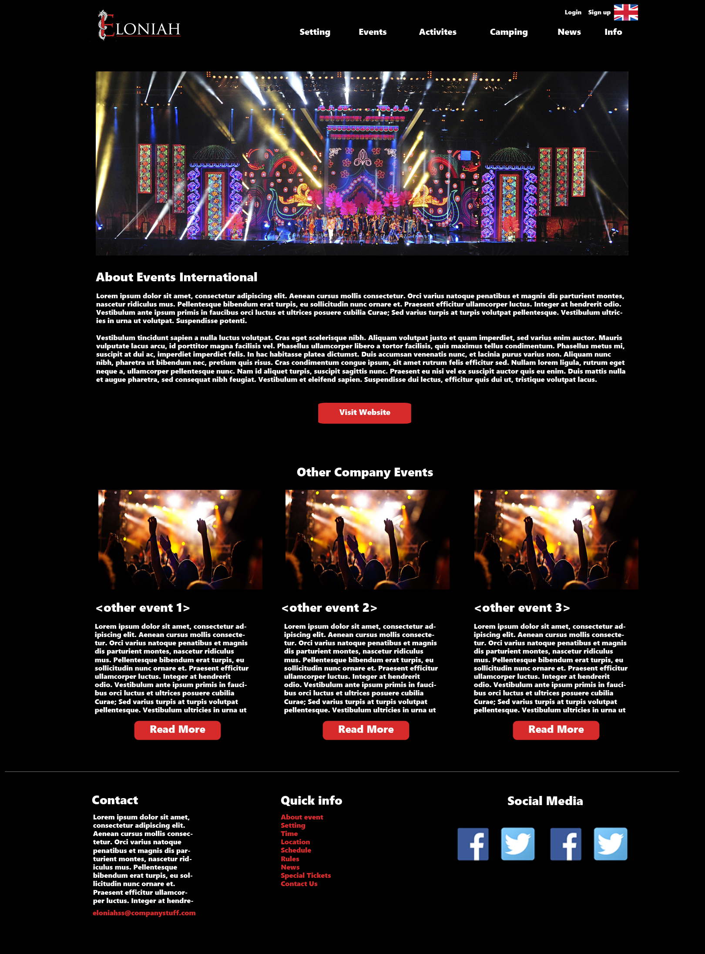

**Login page:**

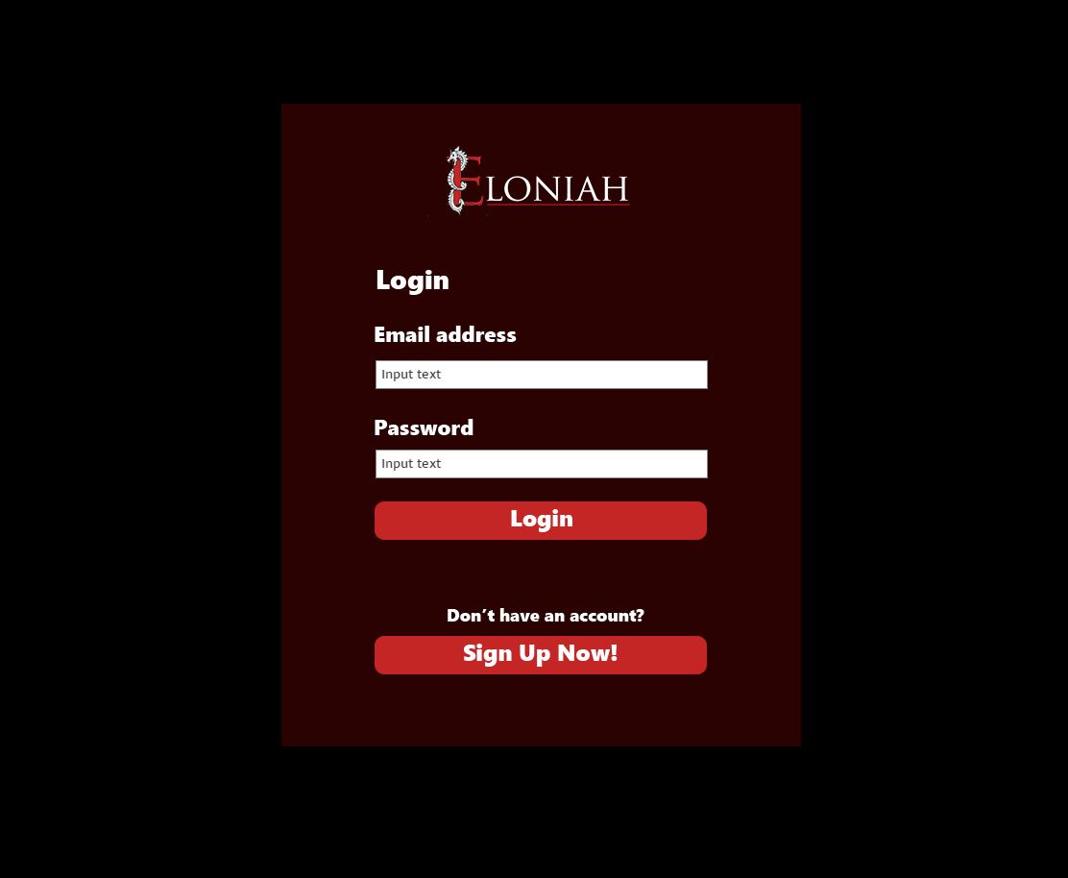

**Sign up page:**

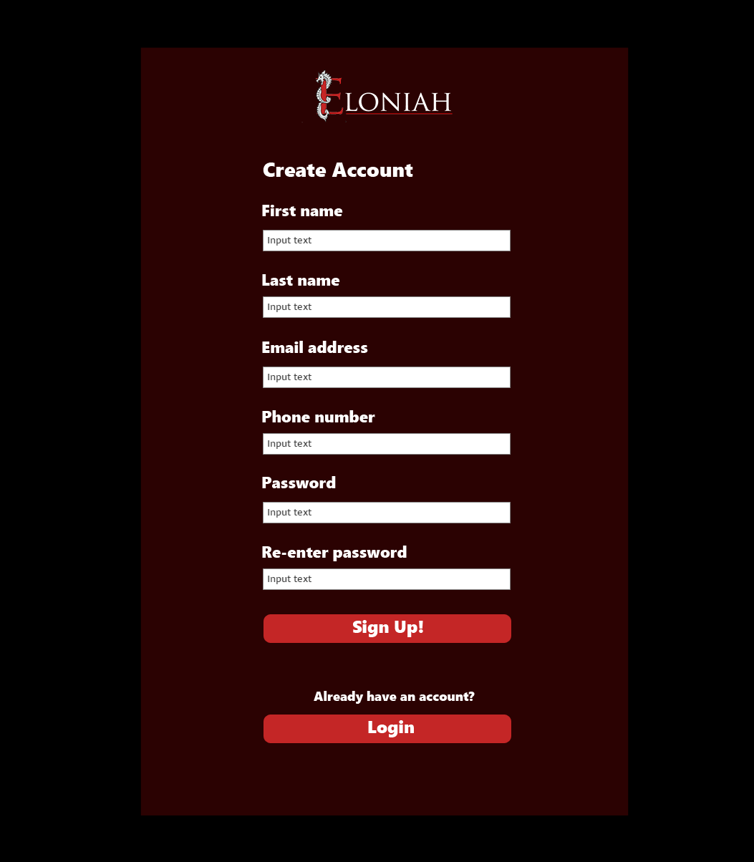

**Participant’s information page** (to show tickets information)

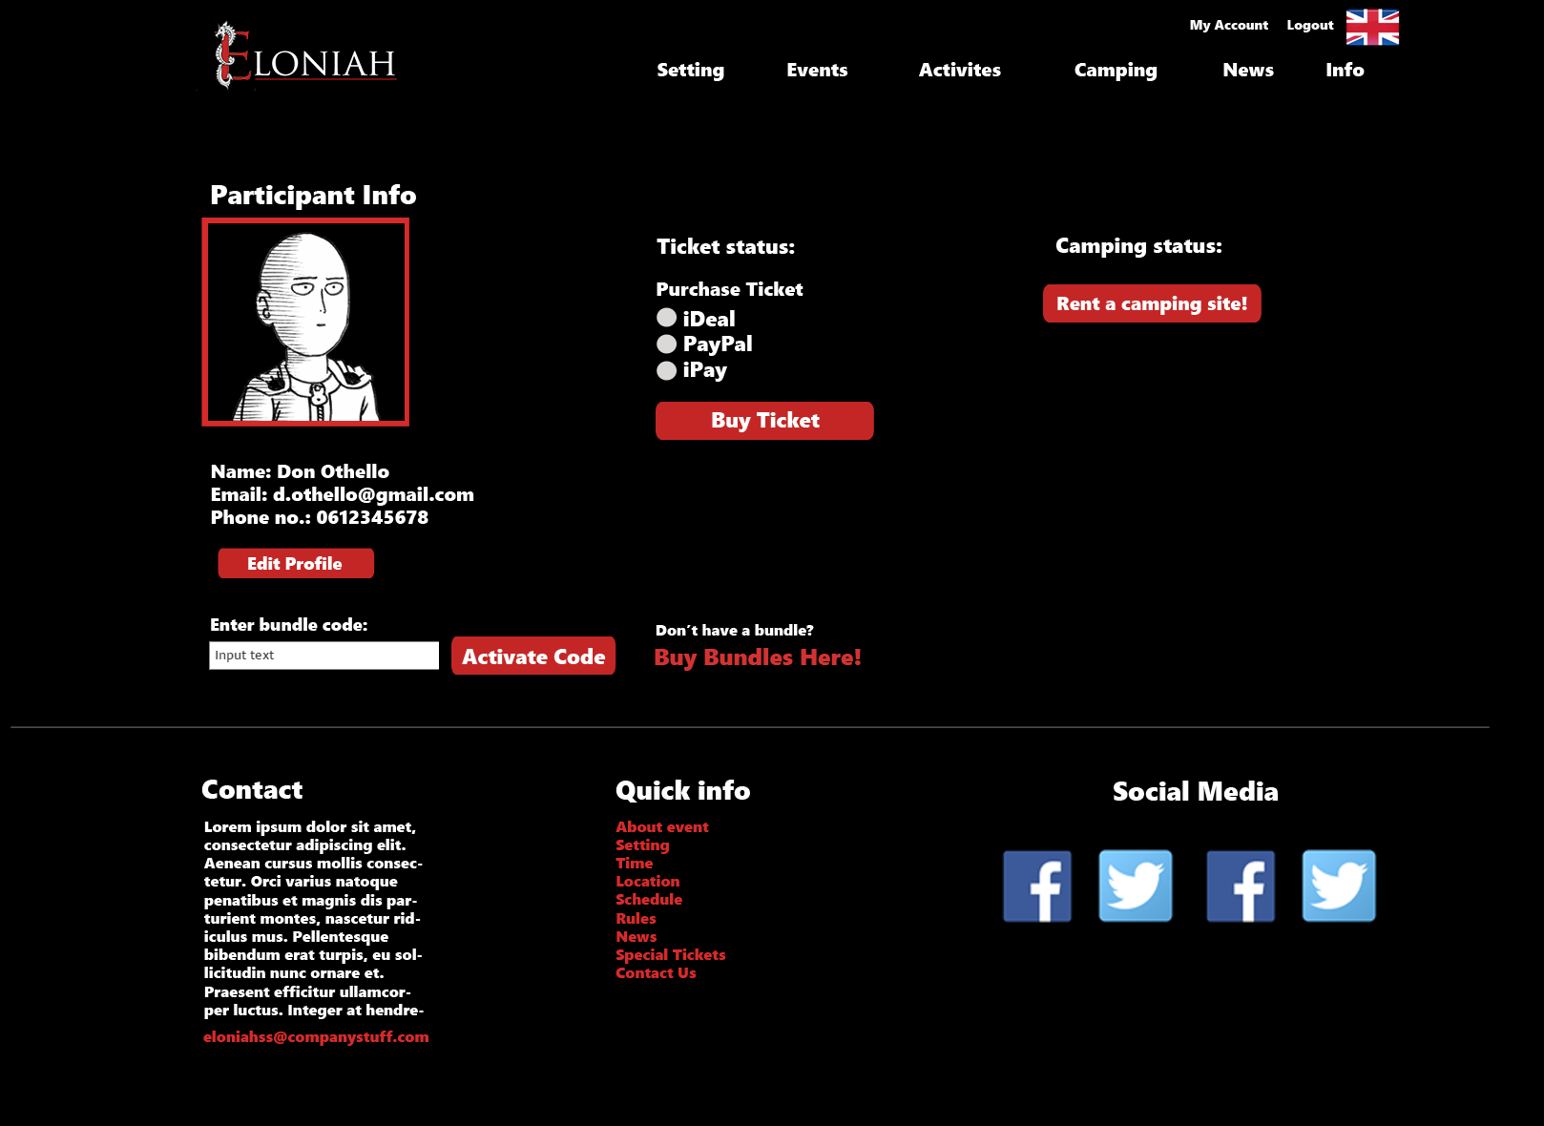

**Participant’s information page** (to show camping information)

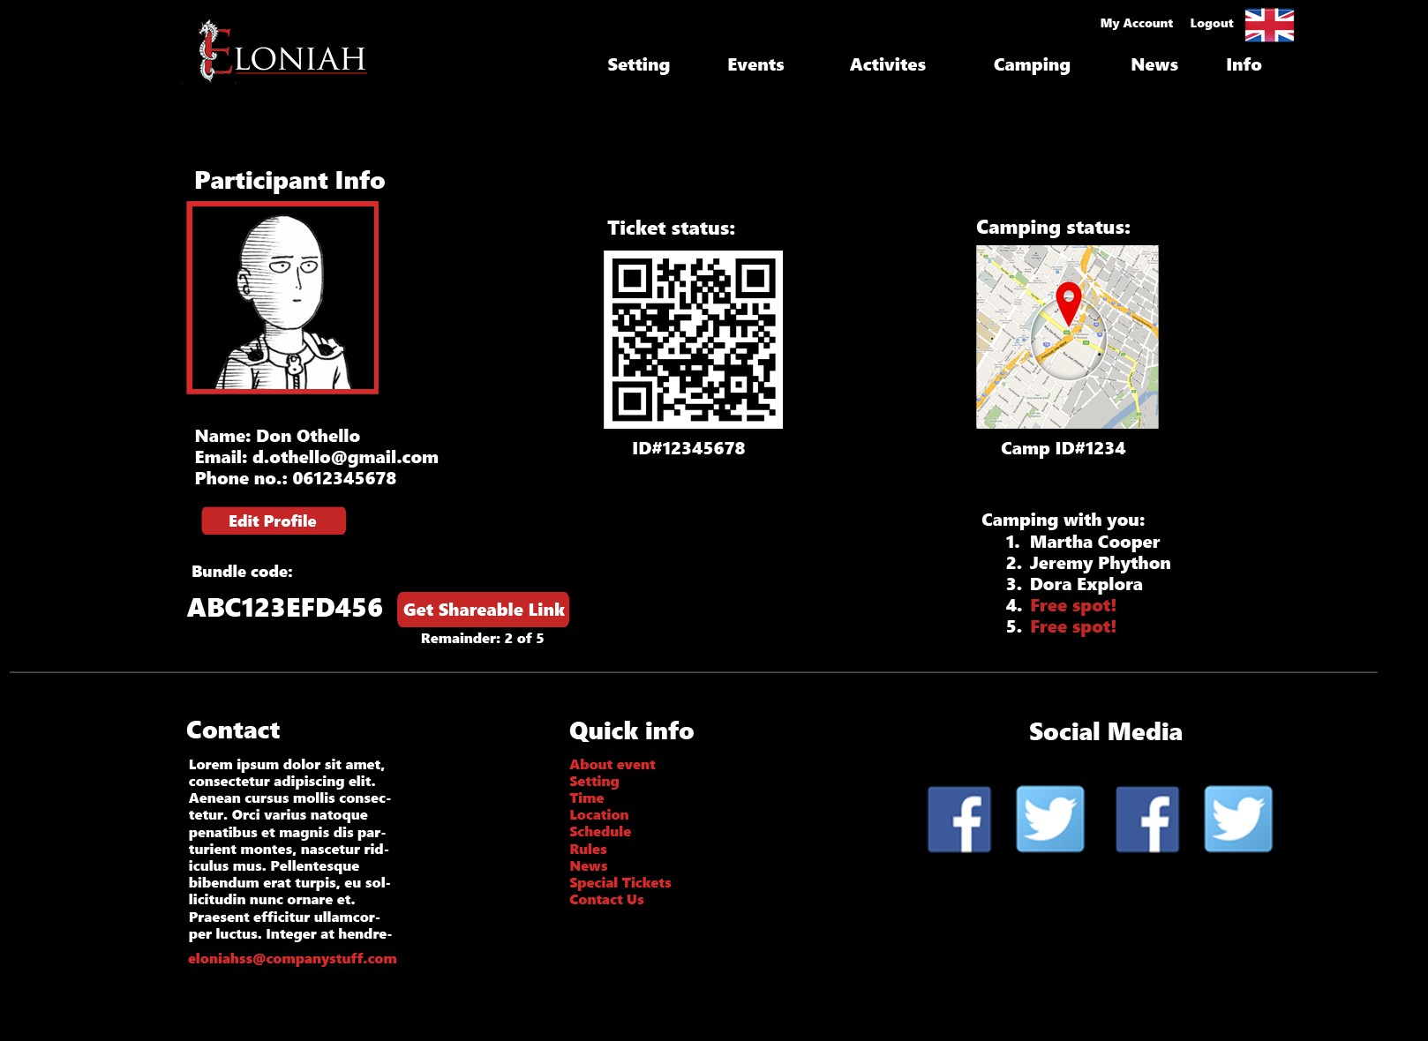

**Camping registration page:**

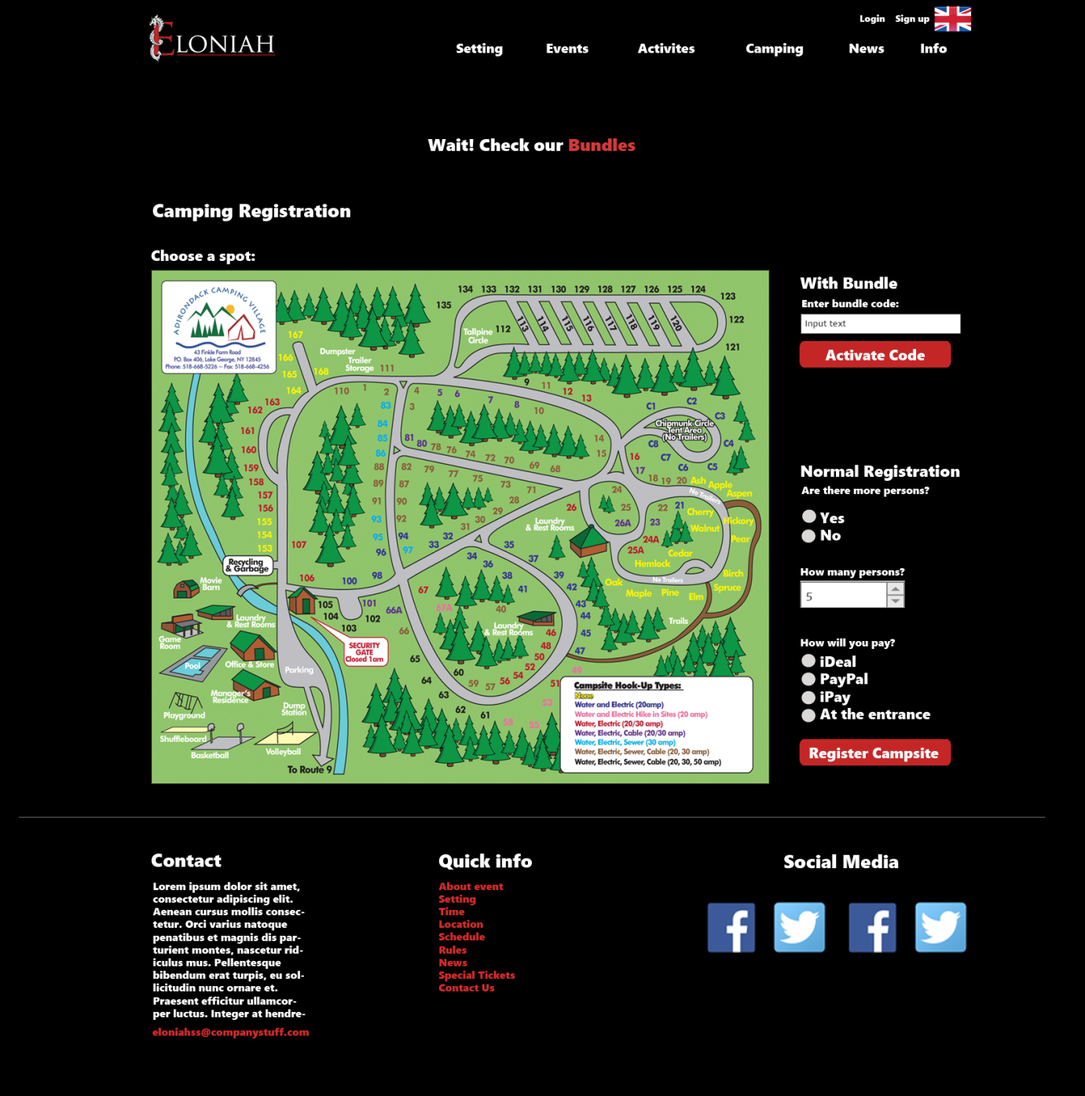

**Bundles page:**

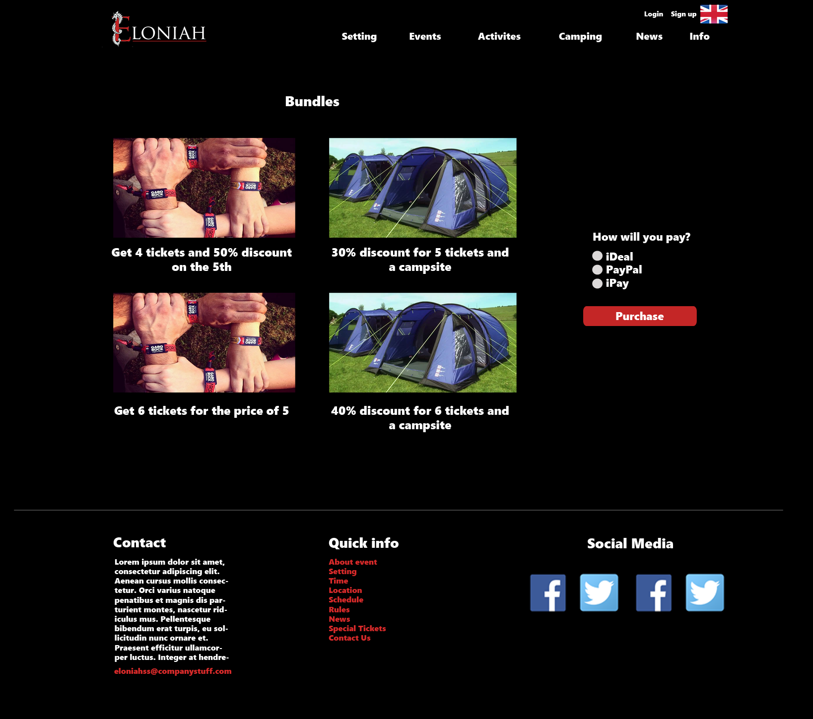

# ERD

* **Red**: The core entities.
* **Green**: The entities supporting the core ones.

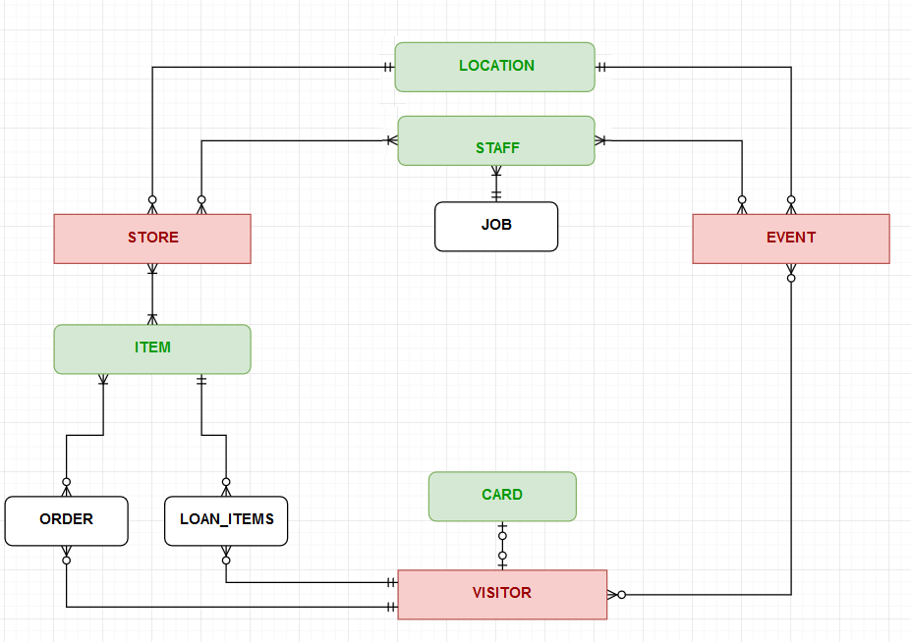

* **Black**: The entities supporting implementation.